How to log into Partner Portal
Creating a new password and logging in
- Type in partnerportal.accfb.org to arrive at the new Welcome page.
- Click “Forgot Password” below the Login button.
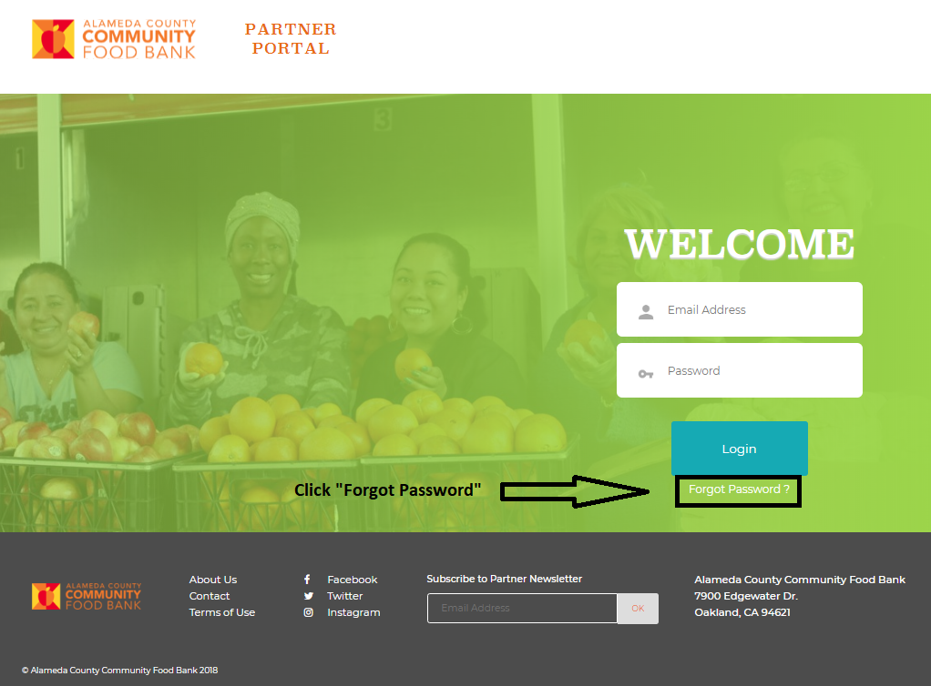
- Type in the e-mail address associated with your ACCFB account. The system will send a link with next steps to the e-mail provided.
  - If you enter the wrong e-mail address, the following notification will appear. Check that you have entered the correct information. If you still receive this notification, contact your Agency Services Representative.
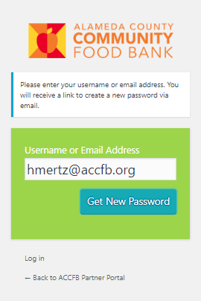 | 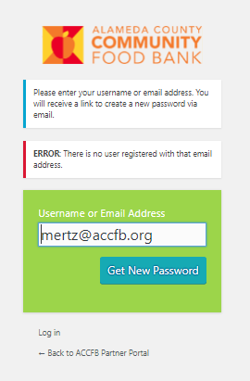

- Check your e-mail for a message from ACCFB Partner Portal.

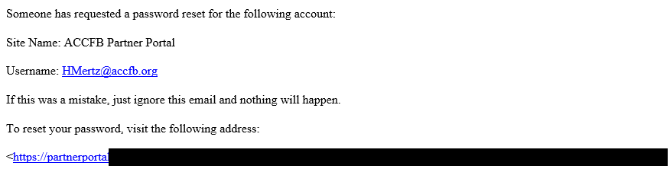

- Delete the randomly generated password provided by the system. Type in your new password and hit Reset Password. Click “Log in” or “Back to ACCFB Partner Portal” on the next page and enter your e-mail and new password to log in.
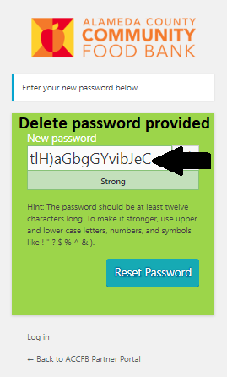 | 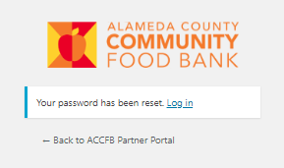
- If you arrive on the Admin Dashboard, click on ACCFB Partner Portal on the top left corner of your screen to get to the home page.
